MM01. Enter the values as shown below.

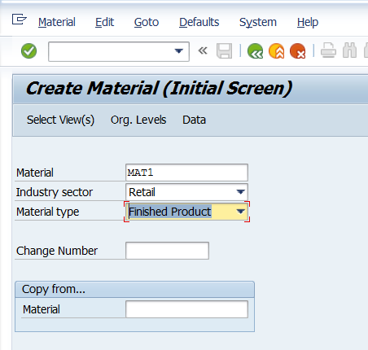

Press Enter.

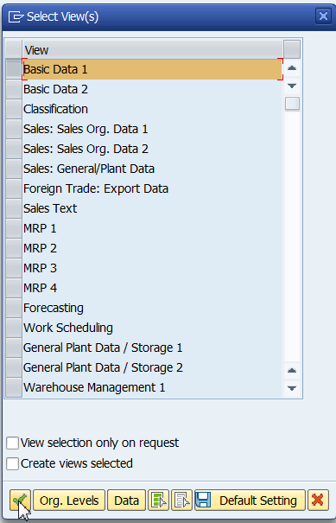

Select Basic Data1 and click on the green tick.

Enter the details as shown below. Click on save.

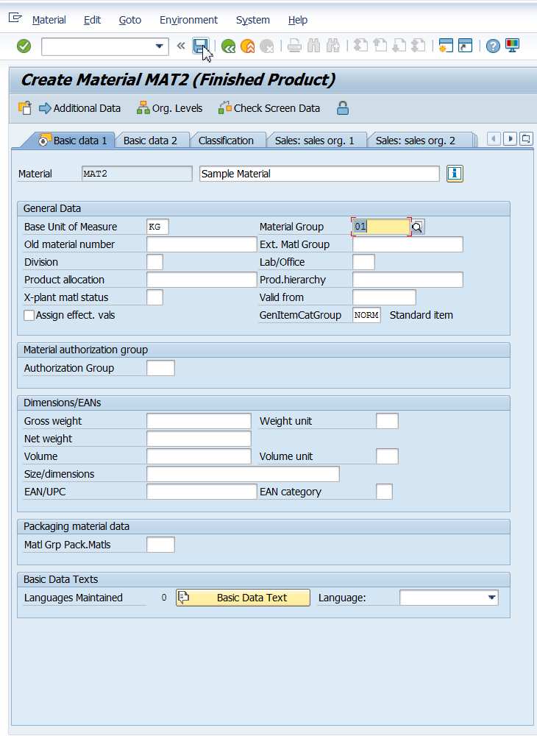

The above steps are to create a material. These may be used to create a BDC recording.

